**Students:** Nadav Spitzer, 302228275. Lior Frenkel, 204728315

**Part 4**

**NER task – With pretrained embeddings**

1. Parameters:
   1. Number of epochs: 6
   2. Learning rate: 1e-3
   3. Batch size: 32
   4. Hidden layer size: 150
   5. Optimizer: Adam
   6. Dropout with 0.5 probability
2. Results:
   1. Train loss: 0.00331
   2. Train accuracy: 84.679%
   3. Validation loss: 0.0049
   4. Validation accuracy: 74.255%
3. Graphs:

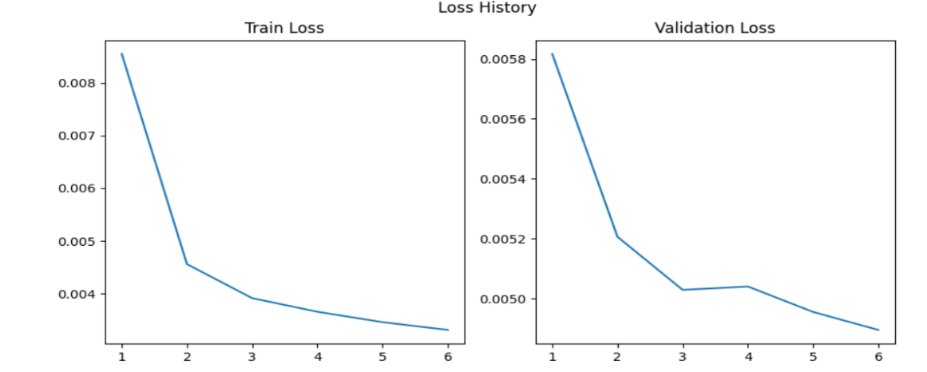

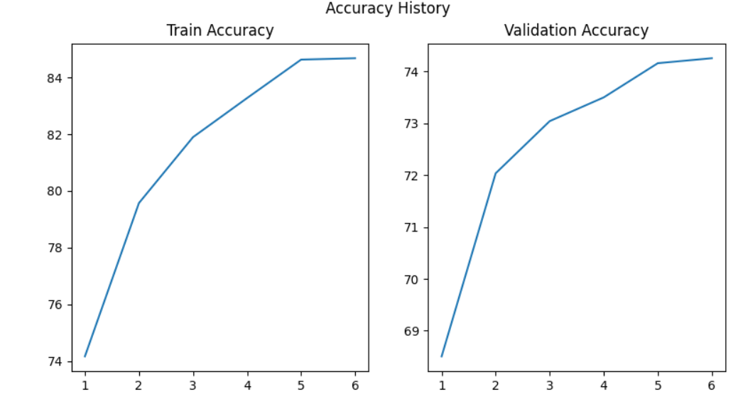

**NER task – Without pretrained embeddings**

1. Parameters:
   1. Number of epochs: 6
   2. Learning rate: 1e-3
   3. Batch size: 32
   4. Hidden layer size: 150
   5. Optimizer: Adam
   6. Dropout with 0.5 probability
2. Results:
   1. Train loss: 0.0027
   2. Train accuracy: 89.504%
   3. Validation loss: 0.00493
   4. Validation accuracy: 73.602%
3. 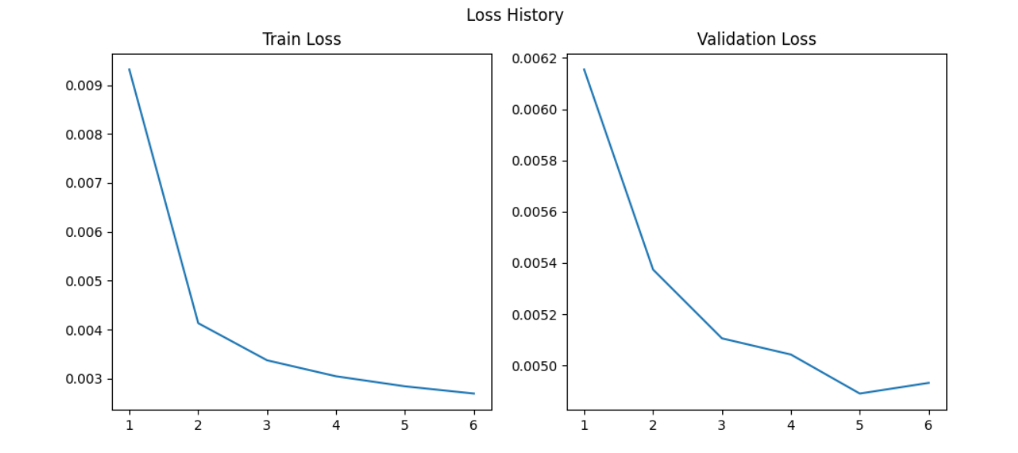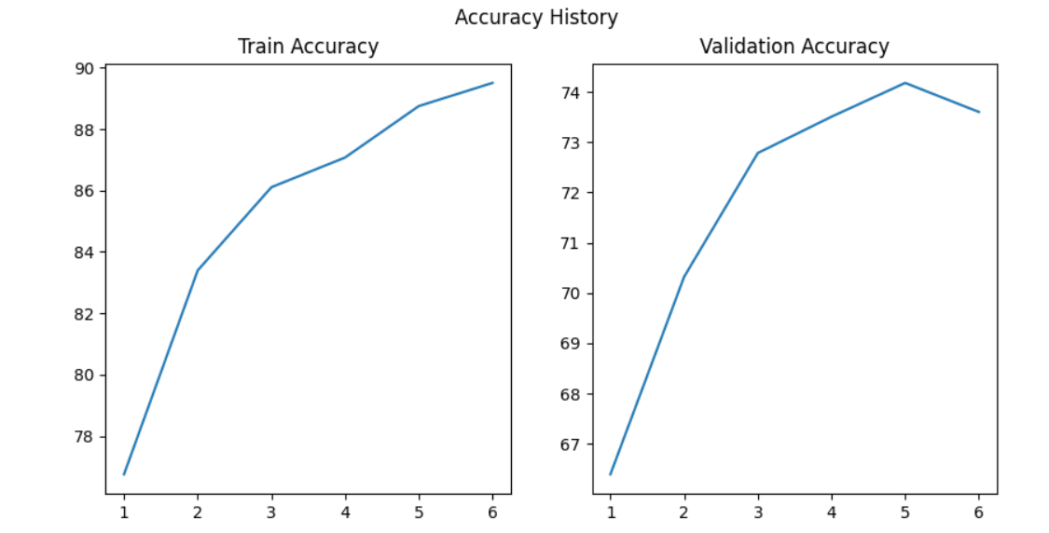 Graphs:

**POS task – With pretrained embeddings**

1. Parameters:
   1. Number of epochs: 7
   2. Learning rate: 1e-3
   3. Batch size: 32
   4. Hidden layer size: 150
   5. Optimizer: Adam
   6. Dropout with 0.5 probability
2. Results:
   1. Train loss: 0.004016
   2. Train accuracy: 96.35%
   3. Validation loss: 0.00564
   4. Validation accuracy: 94.684%
3. 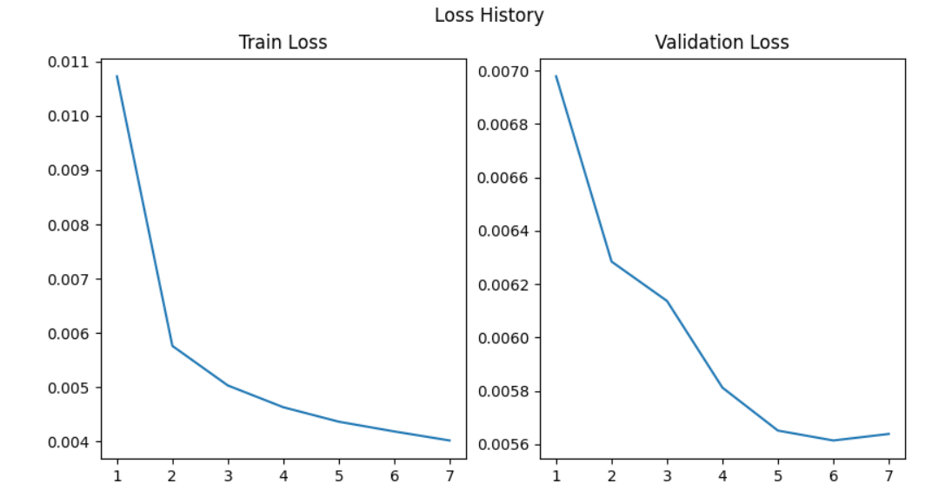Graphs:

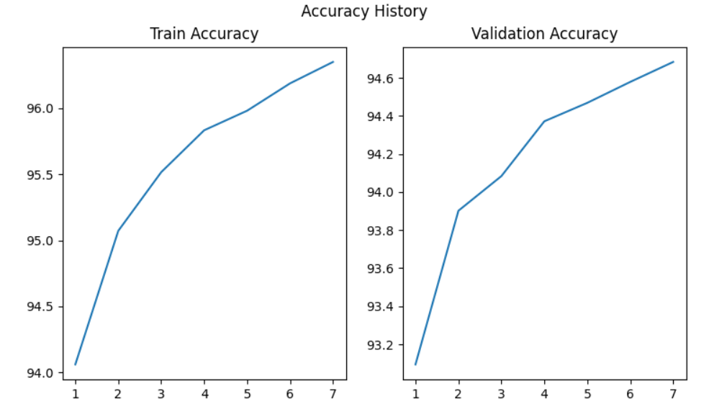

**POS task – Without pretrained embeddings**

1. Parameters:
   1. Number of epochs: 15
   2. Learning rate: 1e-4
   3. Batch size: 32
   4. Hidden layer size: 150
   5. Optimizer: Adam
   6. Dropout with 0.5 probability
2. Results:
   1. Train loss: 0.00436
   2. Train accuracy: 95.882%
   3. Validation loss: 0.005704
   4. Validation accuracy: 94.22%
3. 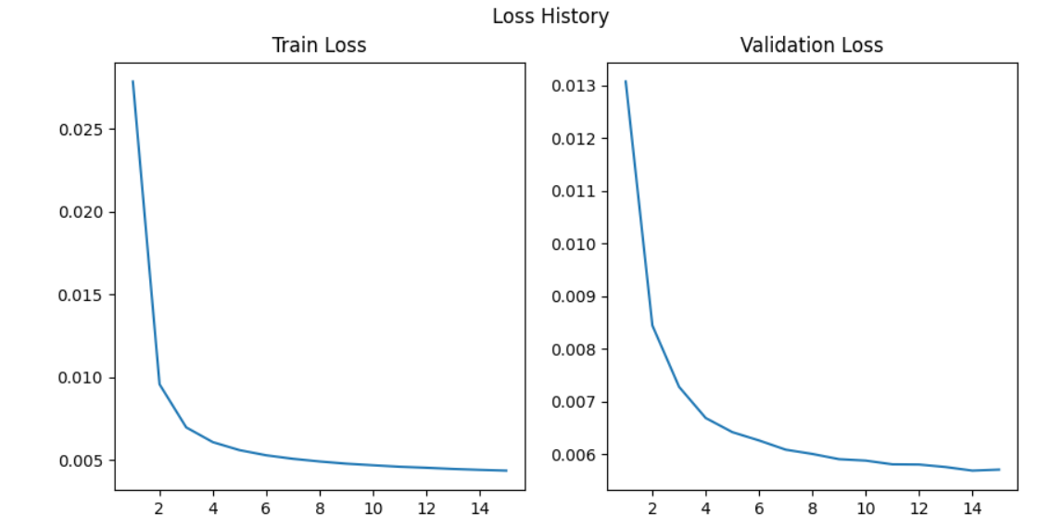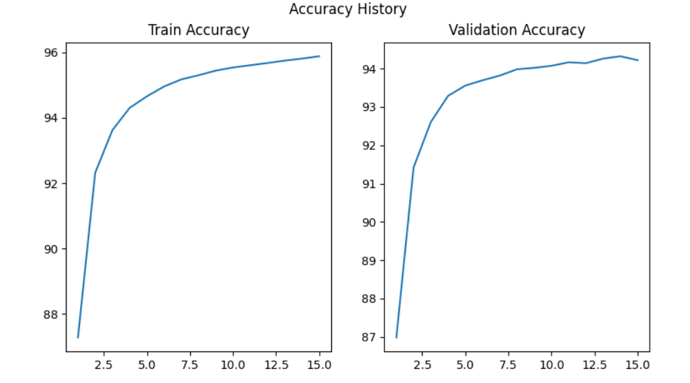Graphs: